**ReadMe.**

Please provide local file system location:

Config Changes: <add key="FileLocation" value="C:\AG\Test\LibrarySample\Resources\" />

Step 1: Run the Library Sample Api

Step 2: please install NuGet package .net.web.Api.cors

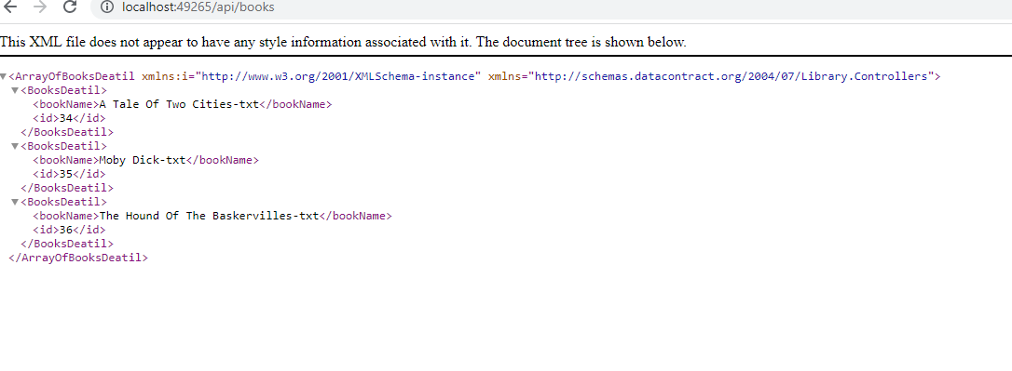

http://localhost:49265/api/books/1/Tes

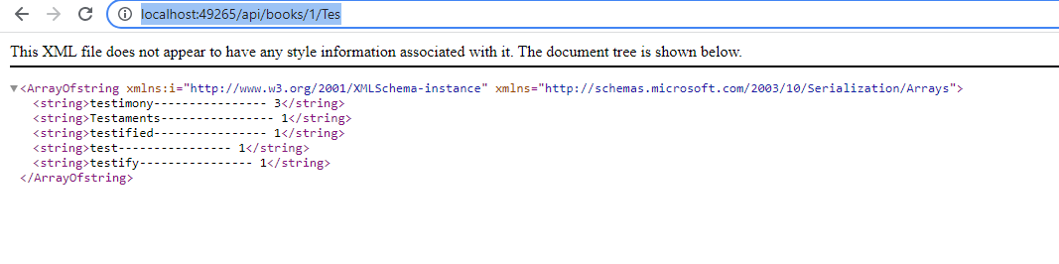

http://localhost:49265/api/books/1/

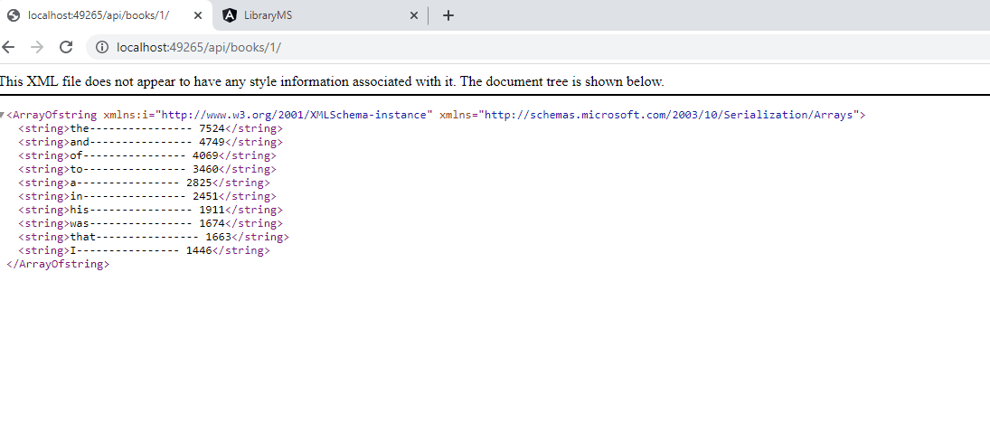

Step 2: Start up UI json Server for Authentication

open terminal window for Client APP UI: LibrarySample\LibraryMS\srd\assets\server

run the Cli : npx json-server -p 5001 serverA.json

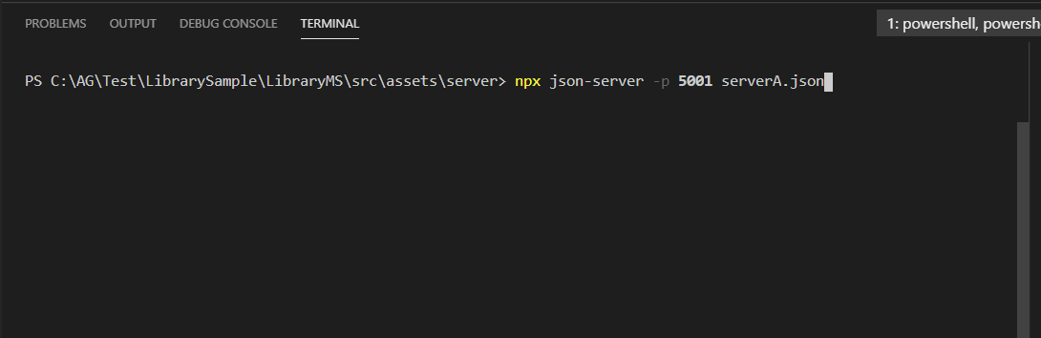

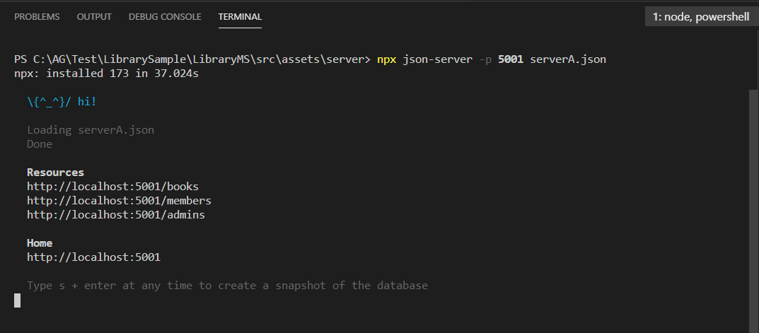

Step 3:

open terminal window for Client APP UI : LibrarySample\LibraryMS

start Application By run cli: 1.npm install

2.npm Start

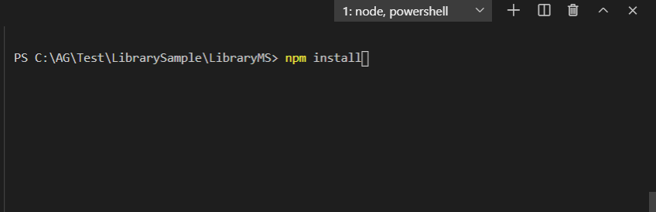

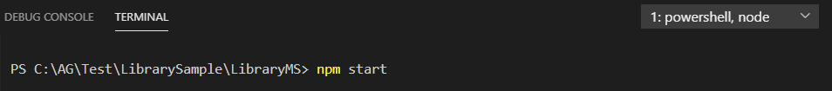

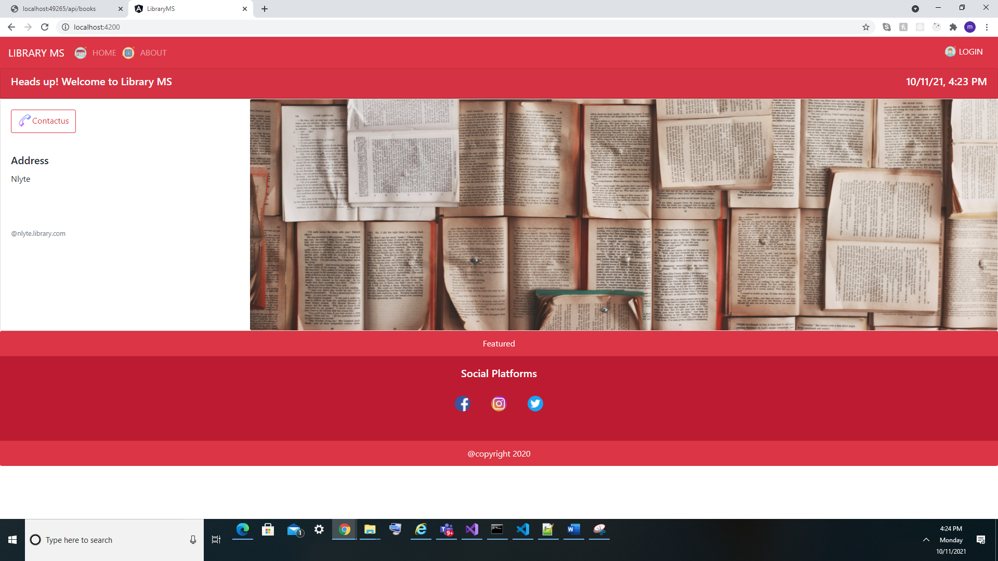

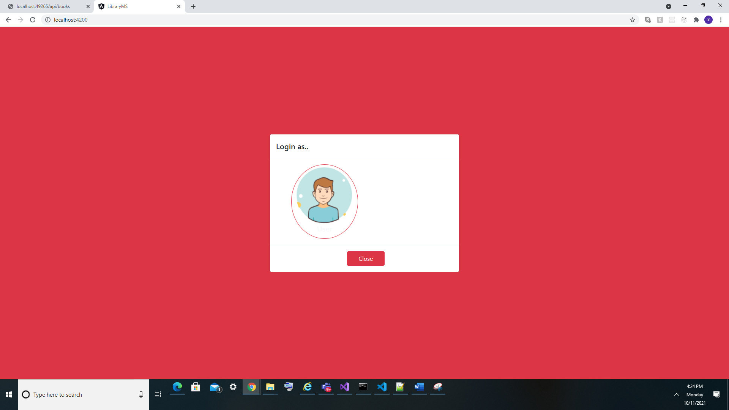

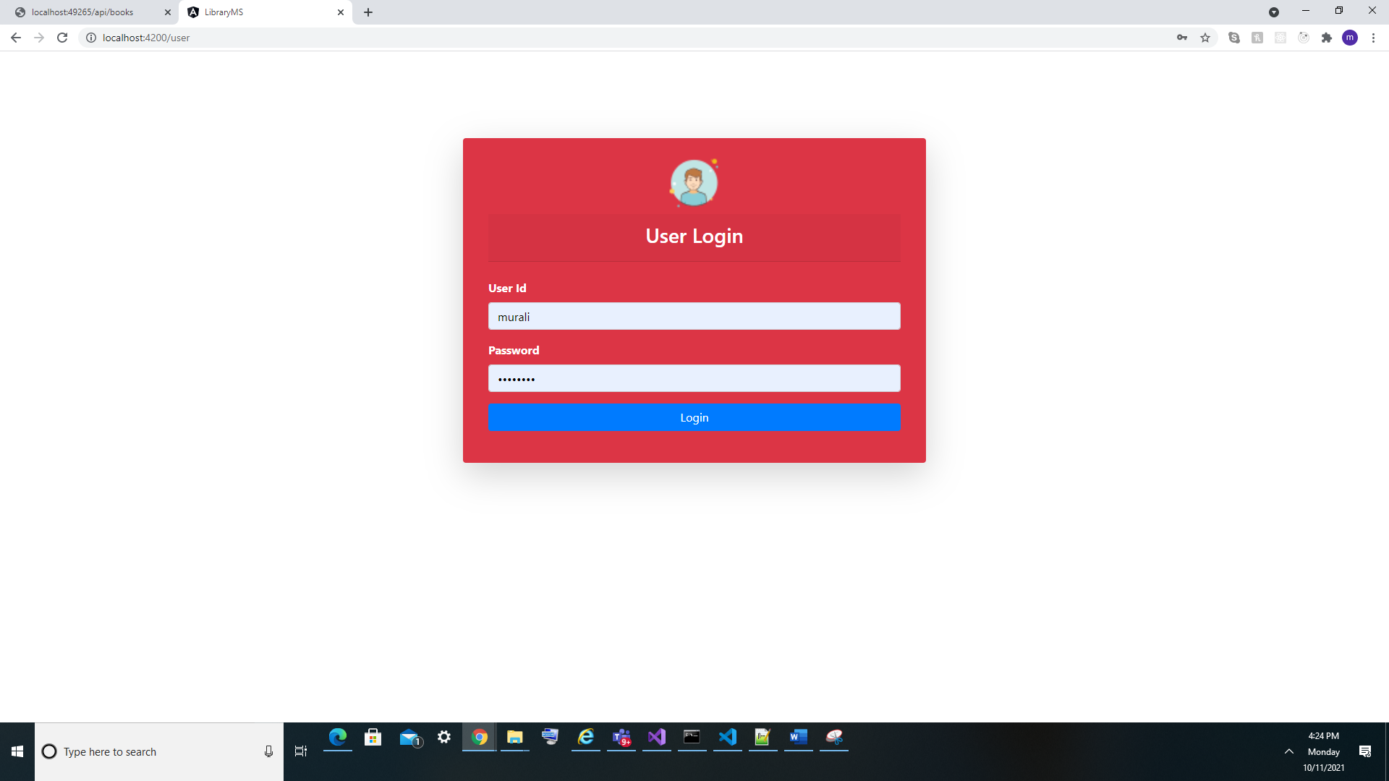

after successfully Launched :

Click Login provide user name and password:

UerName: murali

password: ps123456

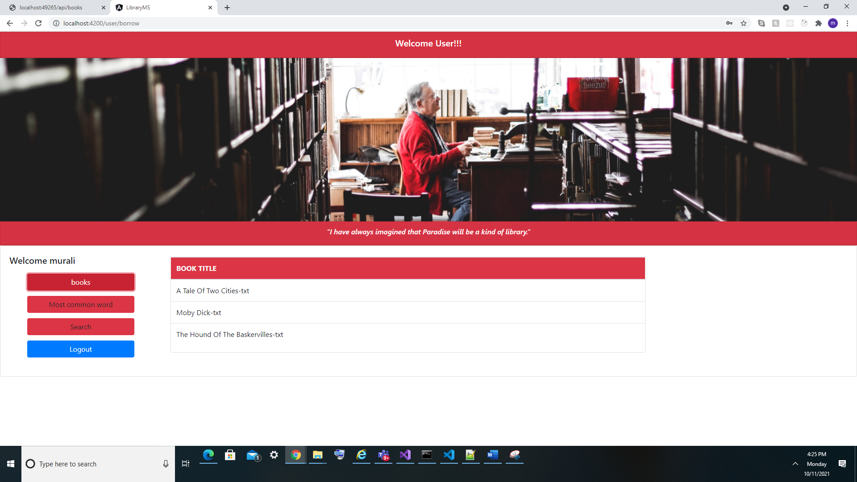

Then Select Book from List:

Most Common word in Selected Book

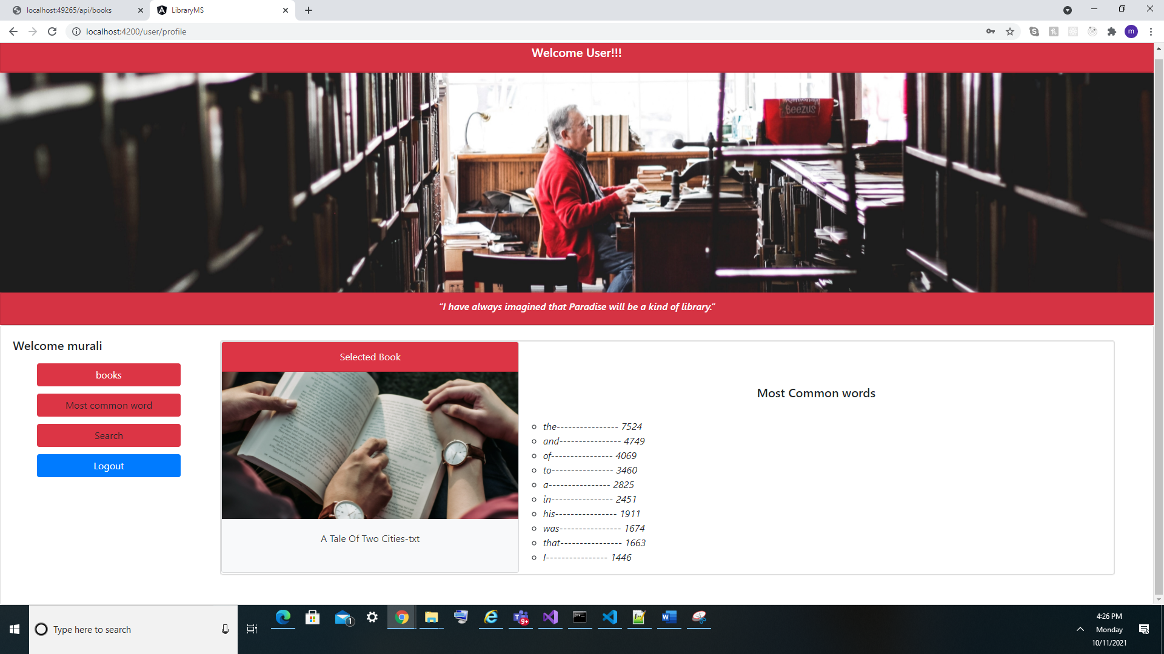

Select left side menu for mode Change for Search and Most common word:

Select for Test Search:

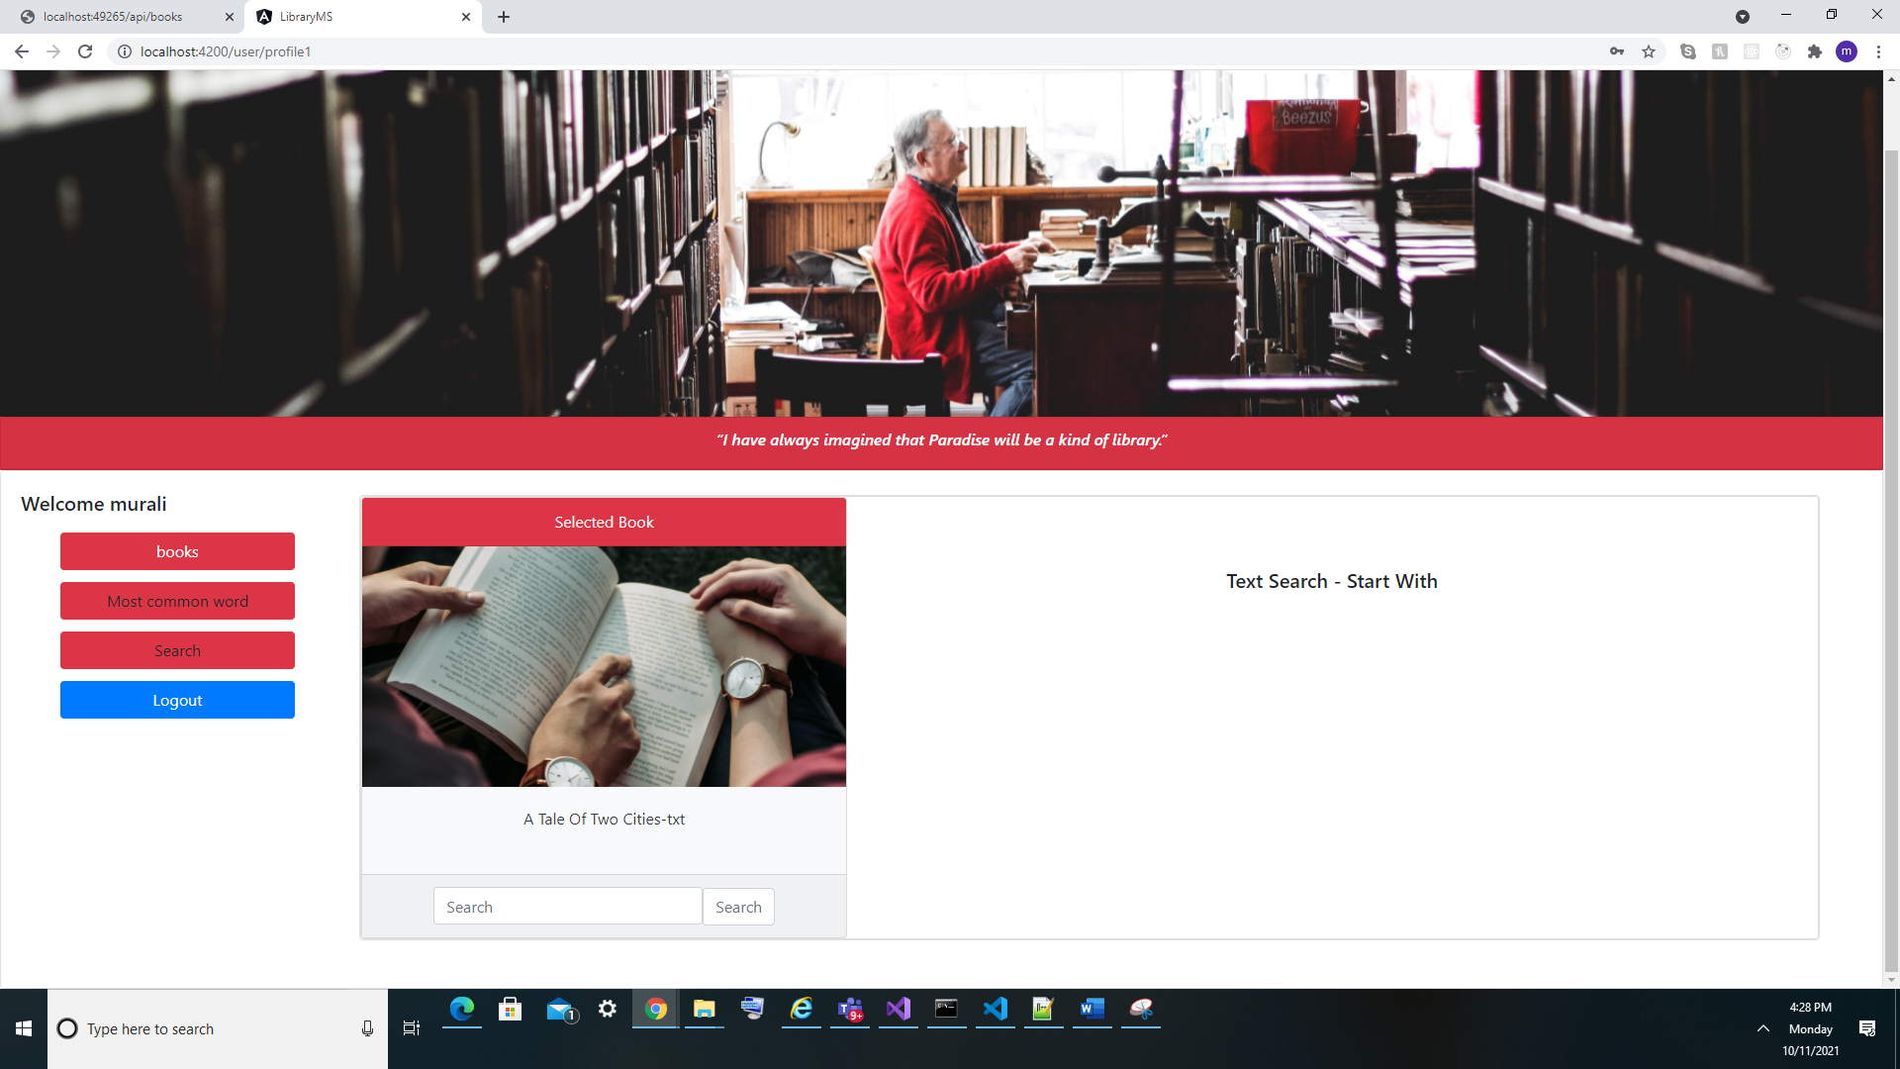

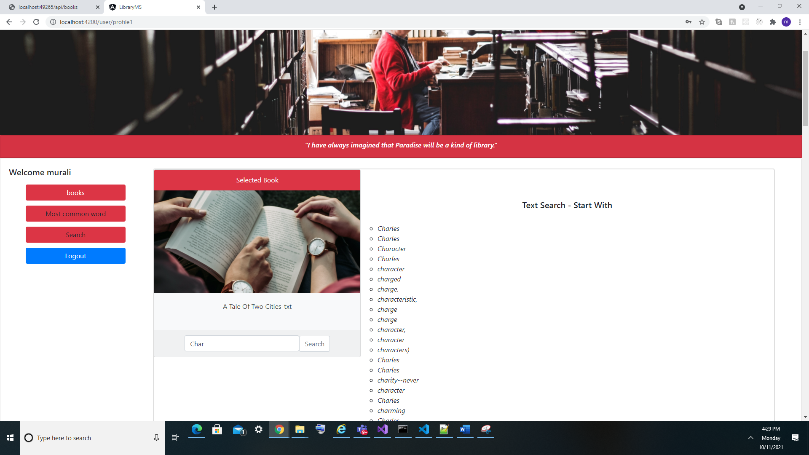

Data does not exist:

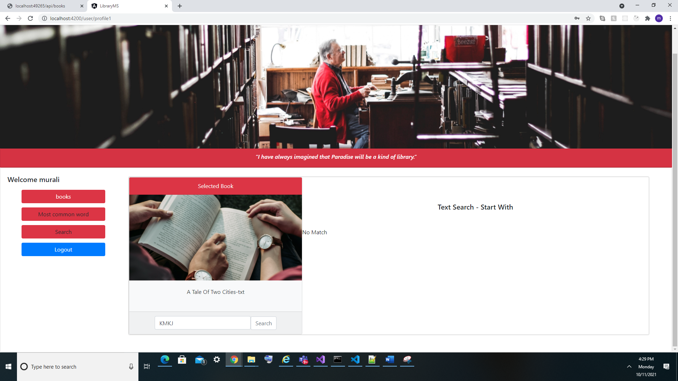

By click the Left side Books Menu. it will display book list

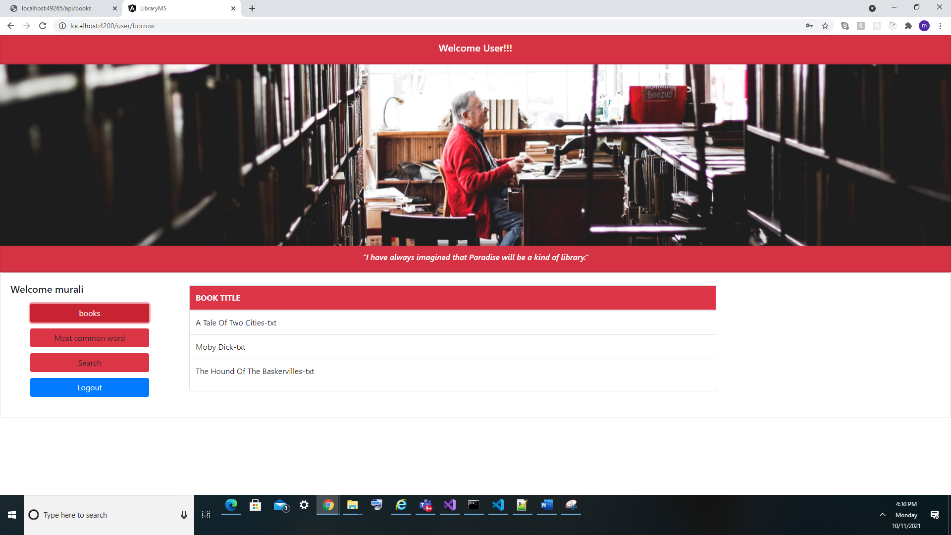

Click Log out menu to logout application

Know Issue:

UI Design Is different